1. Experiments
   1. Unimodal Functions

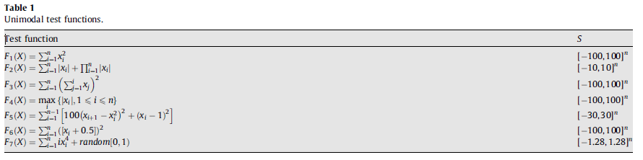

1. Abstract
2. Introduction
3. A Review of Heuristics Algorithms
4. The Law of Gravity
5. Gravitational Search Algorithm
   1. Law of Gravity
   2. Law of Motion
6. Comparative Study
   1. PSO vs GSA
   2. CFA vs GSA
   3. RGA vs PSO
   4. Benchmark Functions
      1. Unimodal Test Functions
      2. Multimodal Test Functions
      3. Multimodal Test Functions with Fixed Dimensions
7. References

Journal: Elsevier

IF:

Pages: 2232-2248

b. Multimodal Functions

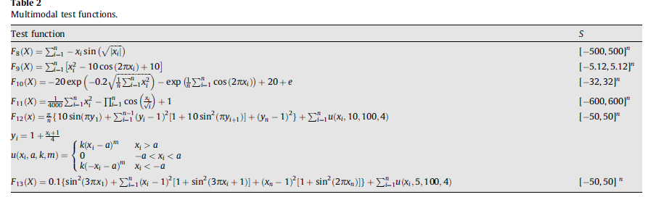

c. Multimodal Functions with Fixed Dimensions

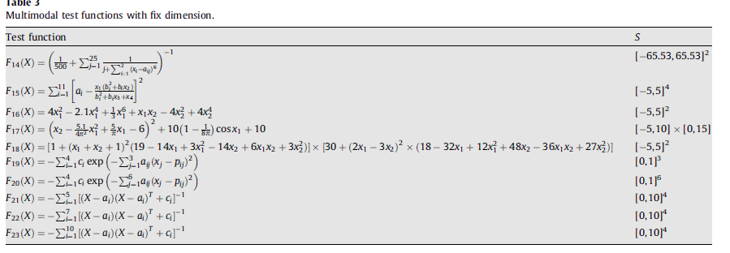

1. Experiments results
   1. Unimodal Functions

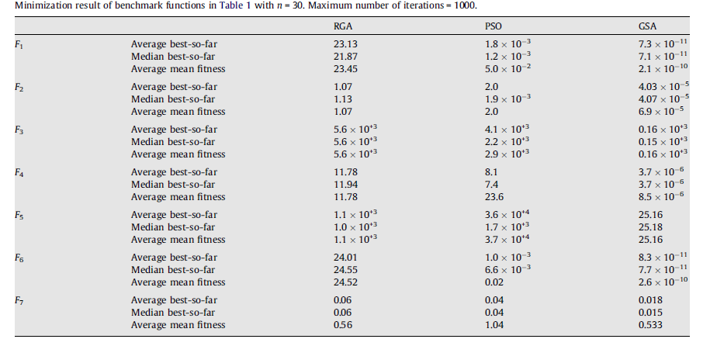

* 1. Multimodal Functions

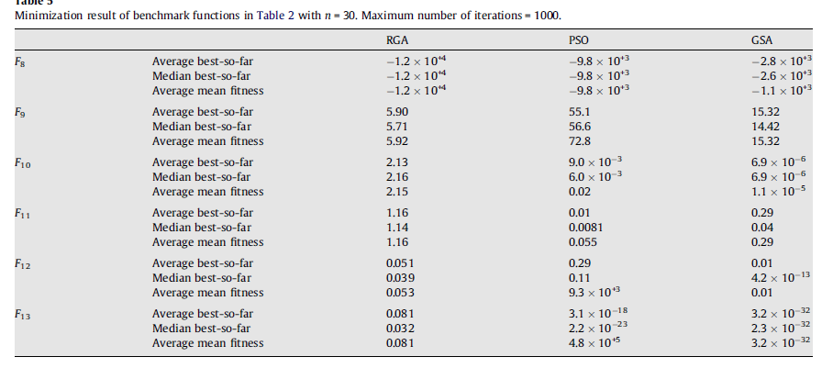

c. Multimodal with Fixed Dimensions

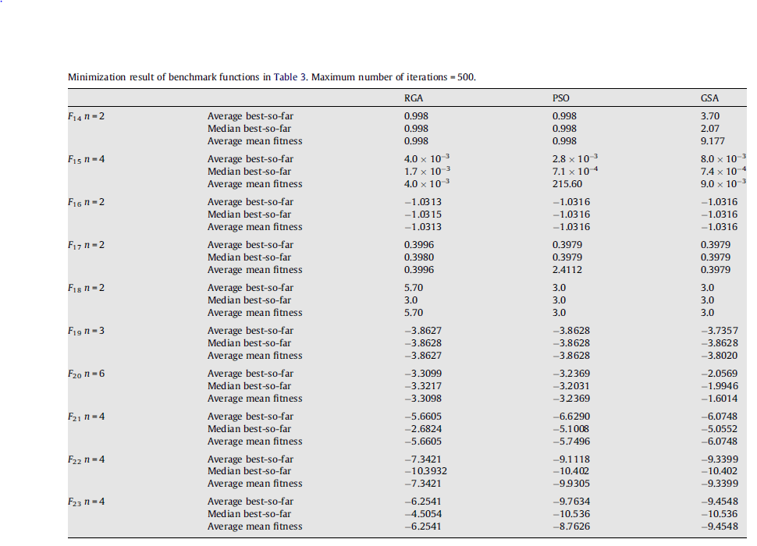

**Brief Summary:**

Gravitational Search Algorithm is inspired by Newton’s Law of Gravity. Every solution is treated as an object and its fitness is determined by its mass. There are four factors that directly inflict impact on this algorithm: Position of object, Inertial Mass, Active Gravitational Mass, Passive   
Gravitational Mass. The objects of light masses are attracted towards objects of heavier masses. Active gravitational mass is a mass of object and passive gravitational mass with respect to first object. Equation of this algorithm is as follows:

F= $G*\frac{ M1*M2}{R^2+ε}$

Where M1 is active gravitational mass of a particle with, M2 is passive gravitational mass, R is Euclidian Distance between two particles. For better results, ‘R’ is used instead of R^2.